Mailbox Detection Pipeline: Agent Design
What each agent does and how it works. Belgium address-to-mailbox detection from GPKG/KML using Street View, parcel geometry and RF-DETR.

1. Overview
The pipeline takes addresses from a GPKG or KML file and returns, for each address, whether the house exists and how many mailboxes it has, written back to GPKG and KML. It is split into six agents. Each agent reads the previous agent's output file and writes its own, so the agents can be built, tested and re-run separately.
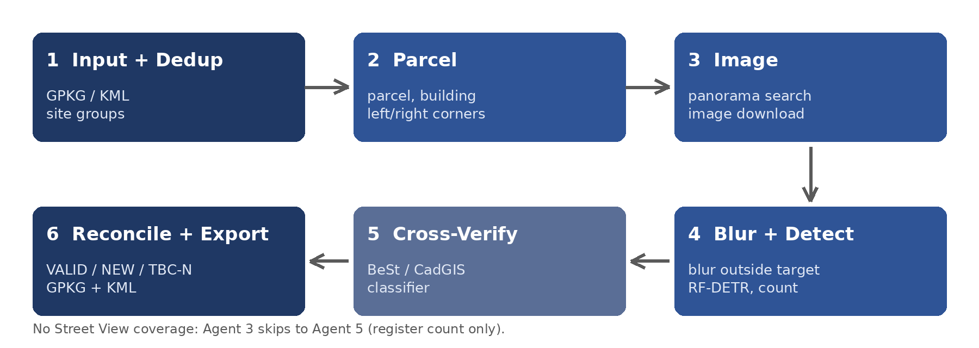
Core idea. In row houses a detector also finds the neighbours' mailboxes. The cadastral parcel gives the left and right corners of the target frontage. Those corners are projected into each Street View image, so only mailboxes inside the target range are counted.

2. The agents

Agent 1: Input + Deduplication
Item | Detail
Purpose | Read the input and make sure each physical address is processed once.
Input | GPKG or KML with addresses and point geometry.
How | 1) Read the file (geopandas; KML is WGS84). 2) Normalise text: lowercase, strip accents, split house number into base, letter suffix and box. 3) Reproject to EPSG:31370. 4) Group by postcode + street + base number (1A, 1B, 1C become one). 5) Confirm spatially: members must be close together or on the same building; otherwise split the group. 6) Assign a site_id and keep the site-to-address mapping.
Output | Site list (site_id, representative point) and a mapping of site_id to all member addresses.
Watch for | Rows with no geometry (log them, do not drop silently). Same base number on different buildings (the spatial check catches this).

Agent 2: Parcel
Item | Detail
Purpose | Turn each site point into the geometry needed to know where the target house is in an image.
Input | Site list from Agent 1; CadGIS parcel layer; building footprints; road layer if available.
How | 1) Point-in-polygon to find the parcel (fallback: nearest parcel within about 15 m, flagged). 2) Find the building footprint by building_id or overlap. 3) Pick the street-facing edge (nearest to the road; without a road layer, keep both endpoints P and Q). 4) Compute frontage length. 5) Count how many sites share the parcel or entrance.
Output | site.json: parcel and building polygons, frontage endpoints, frontage length, flags.
Flags | MULTI_ADDRESS (several sites on one parcel), WIDE_FRONTAGE (over about 12 m), NEAREST_PARCEL, NO_PARCEL.
Note | Which endpoint is left and which is right depends on the camera position, so the order is resolved once the panorama is known (Agent 3).

Agent 3: Image (panorama search + download)
Item | Detail
Purpose | Find usable panoramas and download images aimed at the target frontage.
Input | site.json from Agent 2; Street View API key.
How | 1) Call the Metadata API first (free). Search at the house, then at points in front of it and along the street, with radius 30, 60, 120 m. 2) Score candidates: distance up to about 40 to 50 m, view angle within about 60 degrees of the frontage normal, frontage seen over at least 3 degrees, recent date. 3) Keep the best 3 to 5. 4) Compute heading (bearing to the frontage midpoint) and FOV (angle between the corners plus about 10 degrees). 5) Download only when the metadata status is OK. 6) Save metadata with every image.
Output | Images and images.json: pano_id, panorama position, date, heading, fov, pitch, image width, file path.
No coverage | Status NO_STREETVIEW; no image is requested (a missing-imagery placeholder would look like zero mailboxes). Goes straight to Agent 5.

Agent 4: Blur + Detection
Item | Detail
Purpose | Count only the mailboxes that belong to the target and decide whether the house exists.
Input | site.json and images.json.
How | 1) Convert the left and right corners to bearings from the panorama, then to pixel columns. 2) Add a buffer of about 0.5 to 1 m converted to pixels. 3) Blur everything outside the range (kept as a setting). 4) Run RF-DETR (mailbox, mailbox_bank, door, gate, number_plate). 5) Keep detections whose centre column is in range; check the nearest door is inside the target. 6) Group mailboxes at one entrance as a bank. 7) With two or more panoramas, intersect rays and test the point against the parcel. 8) Decide existence.
Output | Mailbox count, boxes, confidence, which panoramas saw each one, review images (blurred and outlined), existence status.
Existence | EXISTS (building visible in range), NOT_FOUND (empty plot, demolition or different structure; marked TBC/N), UNCLEAR (occluded or old imagery; try another panorama, then review).
Note | A hard blur can cut a real mailbox if the boundary is off by a few metres. Run detection on both the blurred and the clean image on a sample and keep the setting that gives fewer wrong assignments.

Agent 5: Cross-Verify (BeSt / CadGIS classifier)
Item | Detail
Purpose | Check the vision result against the register, and supply a count when images cannot.
Input | Agent 4 result (or NO_STREETVIEW), existing classifier with BeSt API and CadGIS/FPS.
How | Call the classifier for the site, get predicted_type, mailbox_count and confidence, then compare with the vision count.
Output | Final count, count source (VISION, REGISTER or BOTH), flags.

Vision result | Action
N found, classifier gives the same N | Accept; high confidence.
House exists but 0 found | Use the register count; flag FROM_REGISTER; lower confidence. These mailboxes have no observed location.
N found, classifier gives a different count | Flag MISMATCH and send to review.
NO_STREETVIEW | Use the register count; flag NO_IMAGERY.
N found, classifier UNKNOWN | Accept vision; medium confidence.

Agent 6: Reconcile + Export
Item | Detail
Purpose | Map results back to the original list and write the deliverables.
Input | Results from Agents 4 and 5, the Agent 1 mapping, the original input.
How | 1) Copy each site's result to every member address (1A, 1B and 1C all get the answer from one image set). 2) Assign status: VALID (mailbox found and matches an input address), NEW (mailbox found with no matching input address; new record linked to the same site), TBC/N (house not found, or no mailbox and no register count). 3) Build the review queue (MISMATCH, AMBIGUOUS, UNCLEAR, NO_IMAGERY). 4) Write outputs.
Output | GPKG with layers addresses_result, new_mailboxes, review_queue; KML with a style per status (VALID green, NEW blue, TBC/N orange, MISMATCH red) and the image path in each description.

3. Rules across all agents
- One image set per site. Dedup means repeated addresses never trigger repeated downloads.
- No coverage is not zero mailboxes. NO_STREETVIEW is its own status and never counts as a detection result.
- Every agent writes a status. A failed site can be retried without rerunning the others.
- Cache by pano_id. Neighbouring sites reuse panoramas, so metadata and images are cached.
- Store what is needed to reprocess. pano_id, position, date, heading, fov, pitch, image width and file path for every image.

4. Result columns
site_id, status (VALID / NEW / TBC_N), existence, vision_count, classifier_count, final_count, count_source (VISION / REGISTER / BOTH), confidence, flags, pano_ids, image_paths. The original input columns are kept.

5. To confirm before running at scale
- X and Y coordinate system: assumed EPSG:31370; plot a sample on the parcel layer to confirm.
- Meaning of HASLength: not confirmed; not used.
- Dedup key: whether base house number plus the spatial check is enough for your data.
- Definition of NEW: any mailbox with no input address, or only mailboxes beyond the register count.
- Thresholds (distances, angles, buffers): starting values, to be tuned on a hand-labelled sample, especially row houses.
- Google Street View terms of use for storing and processing images at scale.

